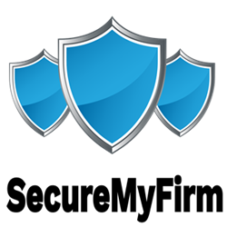 SecureMyFirm Inc.

3336 Glenhurst Ave.

Minneapolis, MN 55416

Tel: 952-922-1120

Email: info@securemyfirm.com

May 15, 2025

<<ClientNameFull>>

<<ClientAddress>><<OptionAddress2>>

<<ClientAddress2>><<OptionAddress2/>>

<<ClientCity>>, <<ClientState>> <<ClientZipcode>>

Re: <<Subject>><<OptionOurFileNo>>

Our File No.: <<OurFileNo>><<OptionOurFileNo/>>

Dear <<ClientFirst>>:

Sincerely,

<<SenderNameFull>>

<<SenderTitle>>